72.09.07
To Joseph Hooker
RBG Kew, Kew correspondence, Australia, Mueller, 1871-81, ff. 59-62.

Melbourne bot Garden
7/9/72
Private
I regret, dear Dr Hooker, that still I have to write you a letter of lamentations, instead of my telling you, as I confidently thought, that the life with its hopes was once more before me. Through the shameless misrepresentations of the Argus Australasian and Leader (against which however I was defended by the whole of the country papers and the remaining portion of the city press,) my position is at present broken up and my Department completely ruined. Nearly half the Votes of the whole establishment have been withdrawn, behind my back, without the slightest consultation with me, to provide for excavations and other earth work in the area of the new Gov House, which has also been taken from me, and that very area where on barren rocky ground I succeeded to establish about 20,000 trees, chiefly the Himalaian & Californian pines, and where I have laid out in years when our budget was better many miles of walks, is now to be withdrawn from my control and to be given over to what illogically is called a "landscape Gardener", though this magnificent Park, entirely created by me, is interjacent to the City & the bot Garden proper! Badly as you have been treated, your treatment is a mere nothing compared to mine! Nevertheless I had no idea, that even a treatment, such as you experienced, you, an English man with the splendor of your own and your fathers name, could happen in Britain anno 1872! — What will an admiring posterity say of the statesman ship of these days. Here the forest Inspector is again to be kept at present out of the forest, as (so they contend!) the season for work had passed! The Argus applauds all these nonesenses and that in our clime of evergreen vegetation! I could not succeed, that the new estimates, laid before Parliament last week, were only withdrawn for a single day, in order that I might point out their ruinous effect on my Department, they being constructed by a hostile outsider, who knows nothing of my Department. This was refused by the Ministry in Parliament, who even construed the request as an act on insubordination of mine, and yet the spirit of the Civil Service Regulation was not in the slightest observed towards myself. My greatest opponent in Parliament is a person, whom you see figured in the left hand corner of the byefollowing picture and who is particularly odious to Mess Wilson & M’Kinnon. That particular person is also the Head of the small clique of Conspirators, who for years worked on my ruin, and who have one or two powerful members as Writers on Mess Wilson & M’Kinnons papers. I really think that Charles Darwin might extend his protection also to me, in as much as he is a near neighbour of Edw. Wilson. As it is here, I have now less then two thousand £ for my whole Department (irrespective of my own starvation Salary, which is only ½ or ⅓ of that of most of my compeers and ruinously taxed both socially & scientifically. Out of these £2000 I can no longer in this expensive country support my laboratory, Museum, Library Branch, supply branch of Nursery &c Indeed I shall have to close the forcing pits and perhaps even the Conservatories! My only clerk is struck off; so I have to write every account myself, copy every letter, nay — as my messenger can also no longer be paid I shall have to bring & fetch myself my letters from town, clear the consignments; and so far as I can see the only horse & cart, to which the Department through M'Cullock's enlightened wisdom was reduced since 3 years has also to be given up. So you see, my generous & dear friend, what can happen to a FRS in her Britannic Majesty's Colony Victoria! As yet no reaction has set in. If I agitate against these measures I shall be persecuted under the Civil Service Regulations
The Argus and Australasian rejoyce in their miserable triumph, altho' even the Leader feels ashamed of itself. Through the "dedication" my main enemy on the Leader has been there dismissed last week
The Proprietors of the A & A stand aloof in Europe. My appeals to them go for nothing As long as they can draw (I suppose) £12000 a year out of their papers, to enjoy themselves in Europe, they seem not to care what becomes of either friend or foe, of either the country or anything else. The idea is monstrous, that all three proprietors should stay away for years & leave the influence of their crushing papers to underlings.
Please use this information cautiously, for you have no idea, what people here are capable of! It is also possible that I may still succeed in turning affairs; but as it is, I am ruined at present. In the small colony of S. Australia even is given for the Adelaide Garden £3,300 with lower wages & longer work hours, and without any scientific branches, while the area is only 40 acres! No distribution of plants there — Our friend Moore has only 80 acres, largely under grass, no conservatory, no laboratory, no real Museum, no extensive distribution of plants to churches, cemeteries, schools, hospitals &c yet he has annually £8000. How can I therefore in this more expensive colony maintain my institution for £2000 — I have long since sold off all private property (land bought as far back as 1847, town allotments (81 acres, in one township alone) to defray the literary and social expenses of my department largely myself. I have nothing left except my position and I am to be robbed of that also now by a landscape Gardener, who is even to get the few hundred £ intended for enlarging my Museum, to which is not added in space for 12 years and where the collections are stand[ing] nailed down under the ceilings & under the tables largely inaccessible, because these few hundred £ are to be devoted also to make new roads for the new Gov. House &c. Yet in the face of this the framer of the estimates succeeded to get £6500 — (six thousand five hundred £) for excavating one single lagoon near the city! merely for a little pleasure boating!
The hostility to me arises largely because I am a foreigner! — Thank God! that I remained unmarried and that I can go to ruin in good conscience. Had I been married I could not have done all my work here, with the miserable votes at my disposal, though the Argus calls them "fabulous", never sufficient even in years when sterling men like David Moore, Haines, Nicholson, OShanassy had the sway. The Ministry is misled and may yet retrace its steps towards me, but courts the support of the Argus As soon as the mail business is done, I will see what further measures I can adopt to protect myself, altho' in the [3] years struggle against the most vulgar intrusion, my very life is almost worried out of me.
Masonry plaid a powerful part against me; the person in the Corner of the background of the picture being actually since years the Colonial Grand Master!! of the Irish Section.
Why do I trouble you with all this? Because I do not wish to stand before a honored colleague like you as the worthless individual, which the Argus & Australasian (or rather 2 or 3 men thereon) make me to appear; and I wish also to show that if I sink to almost nothing for years as a scientific worker, it is because my time has been & is still trifled away in mere defense of the integrity of my Department & the honor of my professional & administrative position.
Major Beddome has been here for a month, to recruit his health, but under the agonies of my troubles I could show him little attention and thus we could not go to the Giant Eucalypts.
I never possessed a single Mining share or speculated in any way. I never yet in my life went to a single race or made a single bet — I worked Sun days & Holidays included regularly 14 hours a day & often much longer. So I could not have done more and have not even a family brought up. So little did I take advantage of the Votes of the Department, that in the 20 years during which Parliament voted me quarters I not even built a single private room!
Always your
Ferd von Mueller

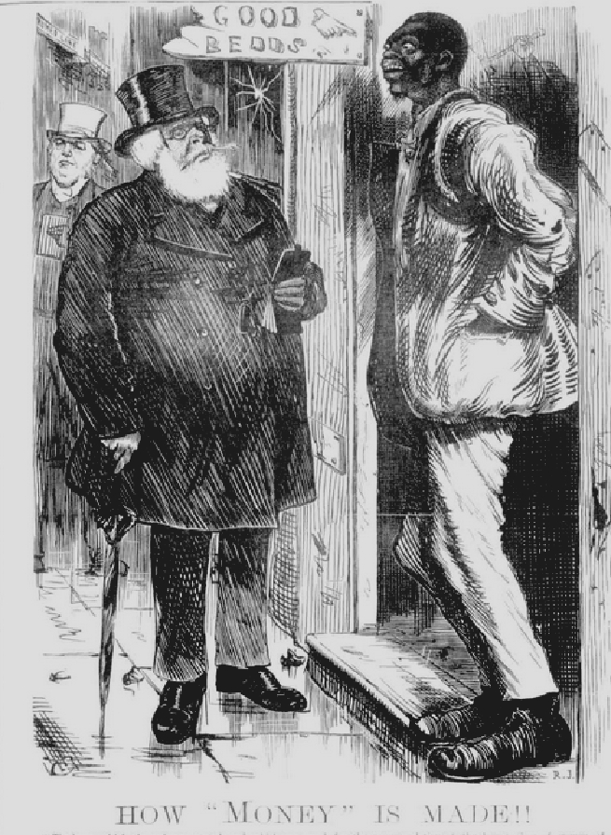
Melbourne Punch, September 1872

Dedicated to the person, who was the leading spirit of the Board of Enquiry concerning the Melb bot Garden. I understand he has now been dismissed from the 'Leader'. One or two of the persons of Mr Wilsons paper were cooperating with him against me.

Each page of the MS is headed 'Private'.
In accordance with recommendations made by Clement Hodgkinson (C. Hodgkinson to J. Casey, 19 August 1872 [in this edition as M72-08-19]), the responsibilities were divided in three: The Inspector of Forests was to be based at Macedon; the Government House Domain was to be separated off from the Botanic Gardens and placed under the control of a curator; Mueller was to be left with a little over 78 acres (62 acres of which were seen as 'garden ground'), with a vote of £1,990 (Victorian parliamentary debates, Assembly, 3 September 1872). See also the debate of 8 August, which resulted in a proposed vote of £1,020 being withdrawn, and of 4 September where the recommendation of the committee taken on September 3 was confirmed. See Cohn & Maroske (1996).
Acton Ayrton, First Commissioner of Works in Gladstone's administration, began a campaign to bring Kew under direct ministerial control, interfering in Hooker's management of the Gardens. Ultimately, after a campaign by Charles Darwin, Charles Lyell and other scientific colleagues, including Sir John Lubbock MP who laid the matter before Parliament, Hooker survived and Ayrton was transferred. See MacLeod (1974).
The Argus ... nonesenses is a marginal note with its intended position indicated by an asterisk.
The estimates were prepared by Clement Hodgkinson.
See M to J. Casey, 4 September 1872, note 3.
See notes 16 and 18; image at note 19.
Edward Wilson settled at Hayes, in Kent, in 1868 and died there in 1878. Hayes is about 6 km NNW of Downe, Darwin's village.
The reference is to James McCulloch's first period as Victorian Premier, from July 1868 to September 1869.
my main enemy ... last week is a marginal note in the central margin f. 61, with the intended position indicated by an asterisk in the text. A second marginal note by M: Through the "dedication", appears in the right margin of f. 61 opposite this paragraph. See note 16 below.
Edward Wilson, Lauchlan MacKinnon, Alan Spowers.
No distribution of plants there is a marginal note with its intended position indicated by an asterisk.
Charles Moore, Director of the Botanic Garden, Sydney.
The land in Mount Gambier purchased by M in 1854? See Transfer of Title, 11 October 1865 (in this edition as 65-10-11b).
Albert Park Lagoon became a popular place in the early 1870s for sailing, but in summer became too shallow to use. In 1872 the government considered a proposal to dredge the lagoon and pump fresh water to it from the Yarra. The proposal was eventually struck off the Estimates in March 1873. See Lamb (1996).
See image at note 19. J. T. Smith was the founding Provincial Grand Master Victoria under the Irish constitution, holding office until his death in 1879 (Lamonby (1906), p. 99). Smith spoke very disparagingly of M in the budget debates on the vote for the Botanic Gardens, describing him as 'behaving tyrannically to his subordinates' (Victorian Parliamentary Debates, vol 13, p. 981, 1871); and as having been permitted to 'receive pay here in order that he might gather honours elsewhere' (vol. 14, p. 1213, 1872).
Beddome reported that he had spent many happy hours botanizing with M; see R. Beddome to J. Hooker, 21 November 1872, RBG Kew, Directors' Correspondence 157/36-37.
Written on a page from the Melbourne Punch, RBG Kew, Miscellaneous reports, Melbourne, Mueller, 1853-96, p.139. (Punch (Melbourne), September 5, 1872, p. 77.) Image at note 19.
M's MS paragraph is a sheet pinned to the page from Melbourne Punch (5 September 1872, p. 77): 72-09-07_image01.jpg The text Punch printed below the caption is "The house which the prisoner rented, and which was used for the accommodation of the lowest class of women of the town, belongs to the Hon Henry Miller, who received £52 a year for the premises. A memorandum of agreement between Bonar (the negro) as a tenant for twelve months, and the Hon Henry Miller, was produced." Argus, August 31.' The quotation is from a report of the trial of Robart Bonar, convicted of keeping a house of ill fame, p. 5. The person depicted in the background is J. T. Smith, MLA, a wealthy publican who was frequently attacked in print by MacKinnon and Wilson, and whom MacKinnon and others accused of making his money 'from sources even less pure than the sale of intoxicating liquors' [ADB]. See also note 16 above. The central figure in the picture, Henry 'Money' Miller, was a wealthy property owner recently retired from politics. However, the ‘leading light’ to whom M refers was someone else, namely Josiah Mitchell; see M to J. Hooker, 31 January 1872. Mitchell chaired the Board of Enquiry and wrote for the Leader. Mitchell continued, however, to write for the Leader until 1873; see Age, 26 August 1881, p. 3. Mitchell and Smith were committee colleagues in a number of agricultural and horticultural organizations at this time.

